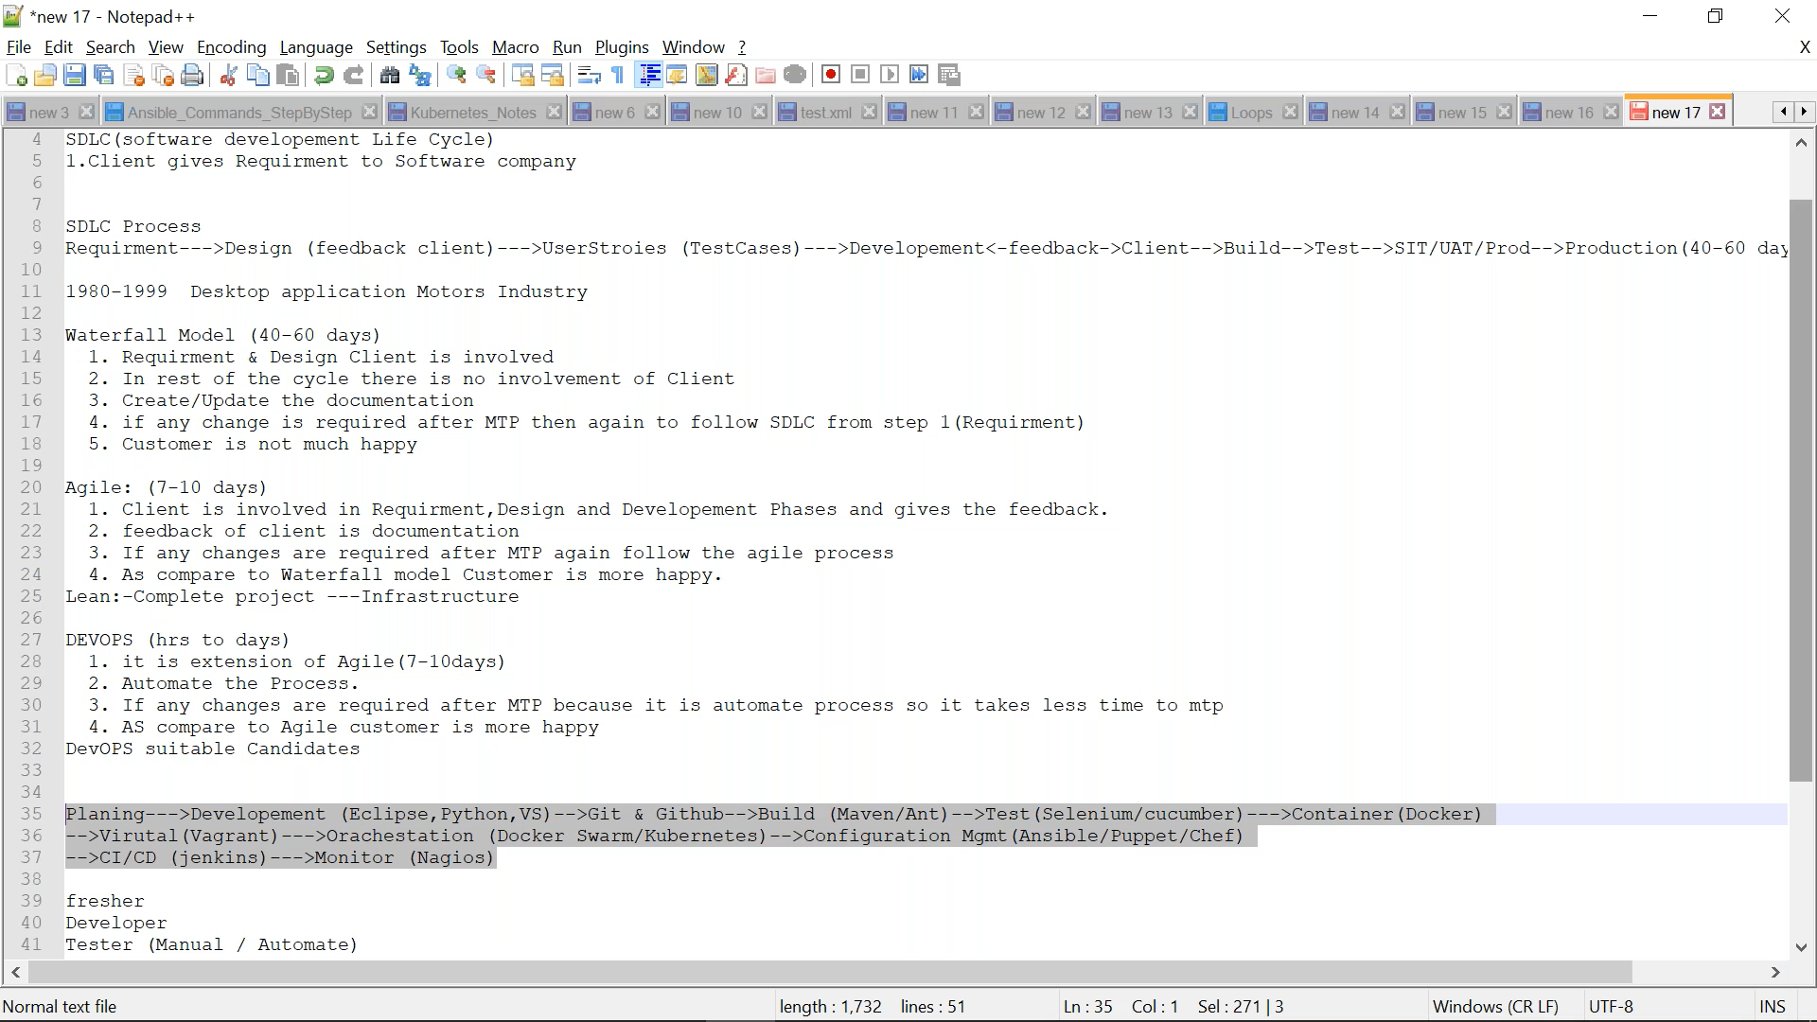

1. As a DevOps Eng. no need to develop code but to help developer in Devops process.
2. Devops is automatic process
3. Git & Github are version control
4. Staging area/testing env. Is called container(tool is docker/vigrant)
5. Orchestation: use to store conatainer
6. Configuration Mngmt (Automated Deployment): if changes need to deploy on 30,000 servers then we can’t do it manually so these tools needed.
7. Virtualization (automated) means Vagrant . Vagrant(tool) is use to create virtualization.
8. **Code .** =this command connect vagrant(tool) to editor(visual basic)
9. vagrant init ubuntu/trusty64 == this command create blank file where we can write/edit setting and if edit word is there means editor comes in picture so visual basic i.e that emptyfile(vagrantfile) is created in linked visual basic.

This vagrantfile we can give to anyone for same setup.

1. Any machine(1) must have SSH (server) to access that machine /enter that machine(by default port is 22). Also machine(2) must have SSH(client)=putty to access/enter into machine(1)

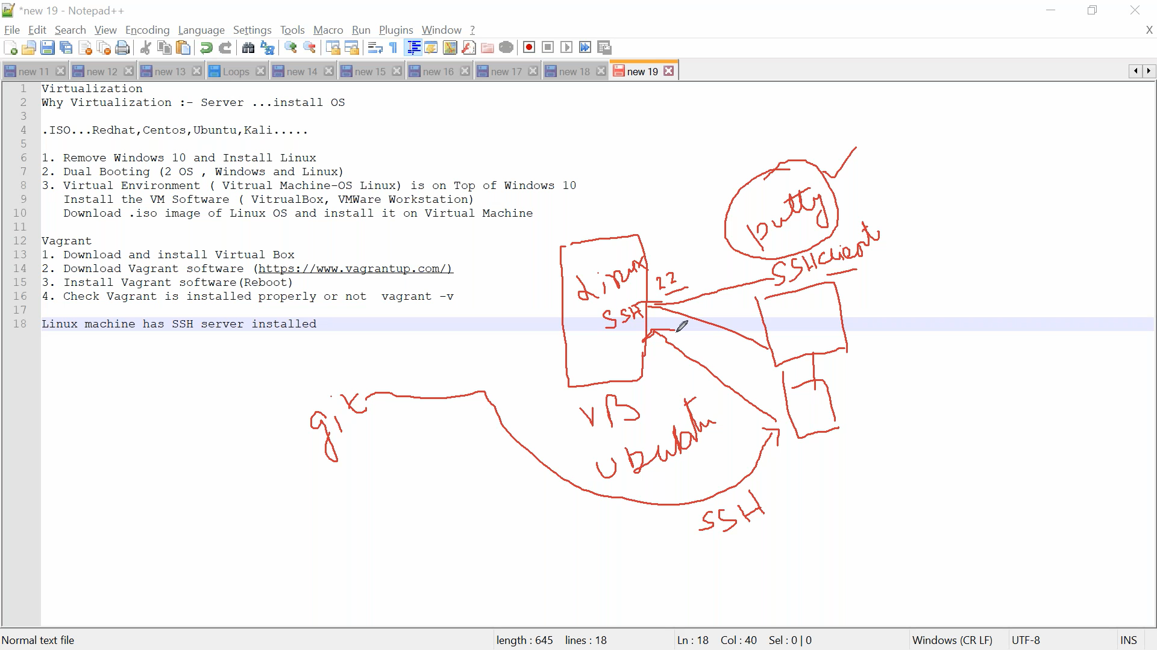

1. Git consist of ssh client too.

**Version Control:**

1. Checkout means download from repo to ur local machine
2. Checkin means upload from ur local machine to repo
3. Checkout/checkin used in central ver. Control
4. Pull/push used in distributed ver control
5. Repo is where versions are maintainted/saved
6. Git is local repo and github is remote repo
7. Need to initialize git for every folder
8. If 2 people downloaded same projects from remote repo then to differentiate branch required.
9. if file data is modified by 1 branch but not commited yet then it can be read by any any branch.
10. U should be the in the branch where u need to merge.
11. In branch log HEAD point out current branch where we are currently
12. Rebase is graphically shows log where merge shows historical logs

**Docker:**

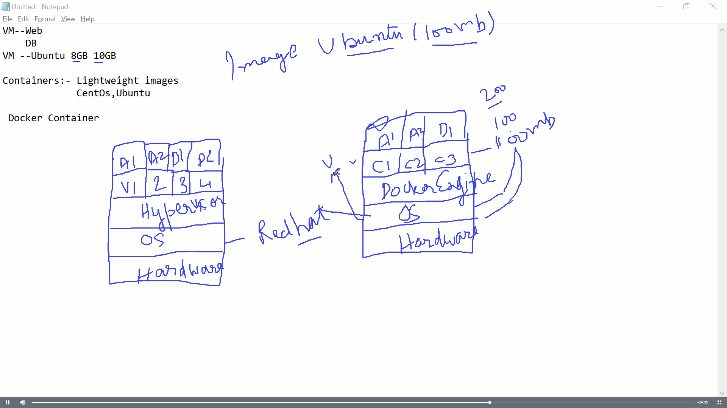

1. Movement of VM is not easy compared to container i.e VM require shutdown time/patching
2. We download image from docker hub and when we run(install) that downloaded image on machine then it called container(installed OS)
3. No difference between stop & kill command for container stopping. Kill means forcefully

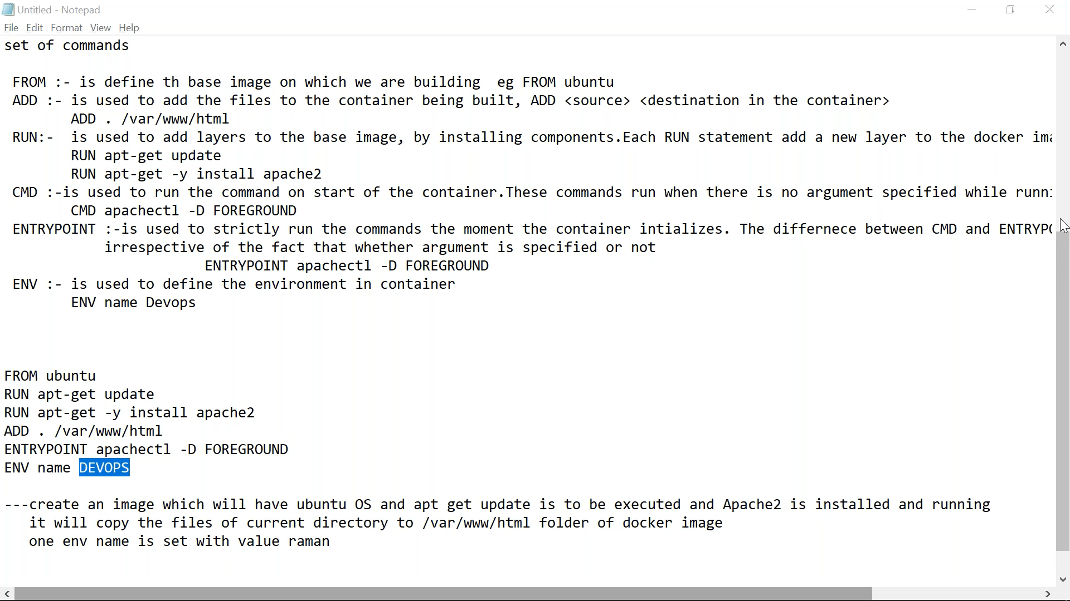

**DockerComposer**

1. Docker file is use for creating images
2. DOckercomposer: contains multiple containres having some dependancies on each other
3. For docker composer we need to download docker composer first and nedd to give permission
4. sudo curl -L "https://github.com/docker/compose/releases/download/1.23.2/docker-compose-$(uname -s)-$(uname -m)" -o /usr/local/bin/docker-compose : to download docker file where sudo curl is to go for https
5. YAML : Programming lang. developed in python
6. Extension is .yaml or .yml
7. Better to use small letters in yaml its standard
8. Ex:

version: "3.7"

services:

web:

image: nginx

db:

image: postgres

1. If want more that one instance of any image then –scale=nos.
2. Depends_on field in yaml script is to create dependencies with other images/containers
3. Dockercomposer maintain container not images so if u shutdown docker composer then it will remove containers and not its images
4. **Docker registry**
5. Docker registry is for to download images offline/in ur network hub instead of dockerhub as internet not available
6. Need to run registry:2 image on container to create docker registry
7. Then u can push/pull images on this local registry (registry:2)
8. It runs on 5000 port.
9. It always started
10. How many registry we cannot find in single command
11. **Container orchestration**
12. Docker swarm is tool for container orchestration
13. Cluster: Multiple machines connected to each othen in same n/w
14. Overall if any service goes down it will make it up automatically
15. 1st step is to join slave nodes with master
16. If there are 3 same services/containers are running then out 3 any one/two run on slave and remaining will run on master.
17. If u remove or removed by mistake and latter u check again automatically it will be created so can’t remove if docker swarm is installed. Thus is it is called container orchestration(maintainace of container)
18. **Configuration management**

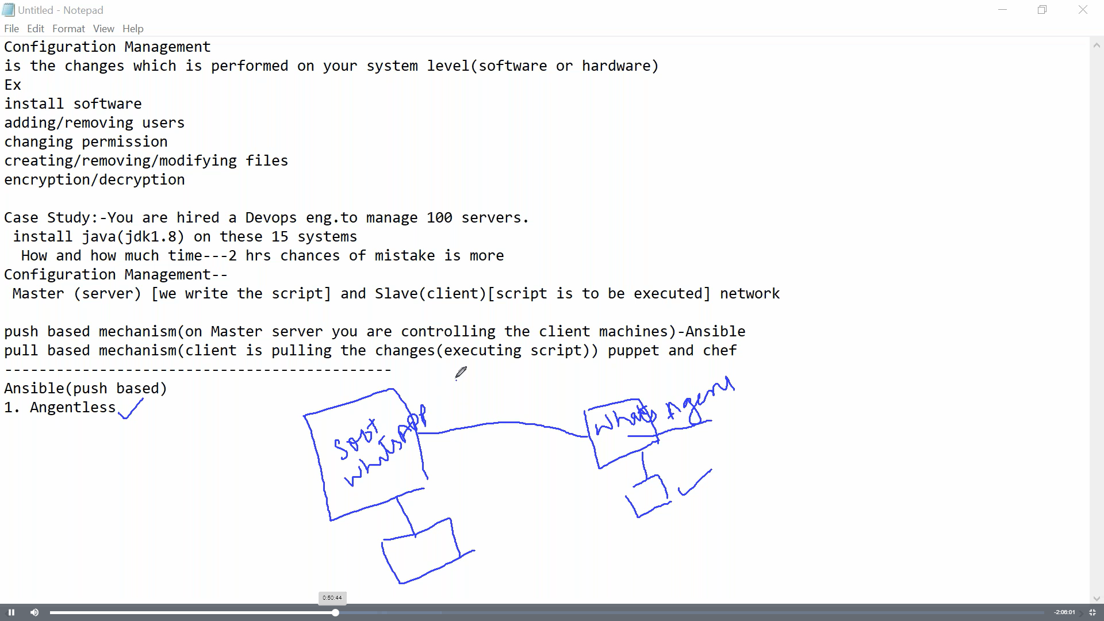

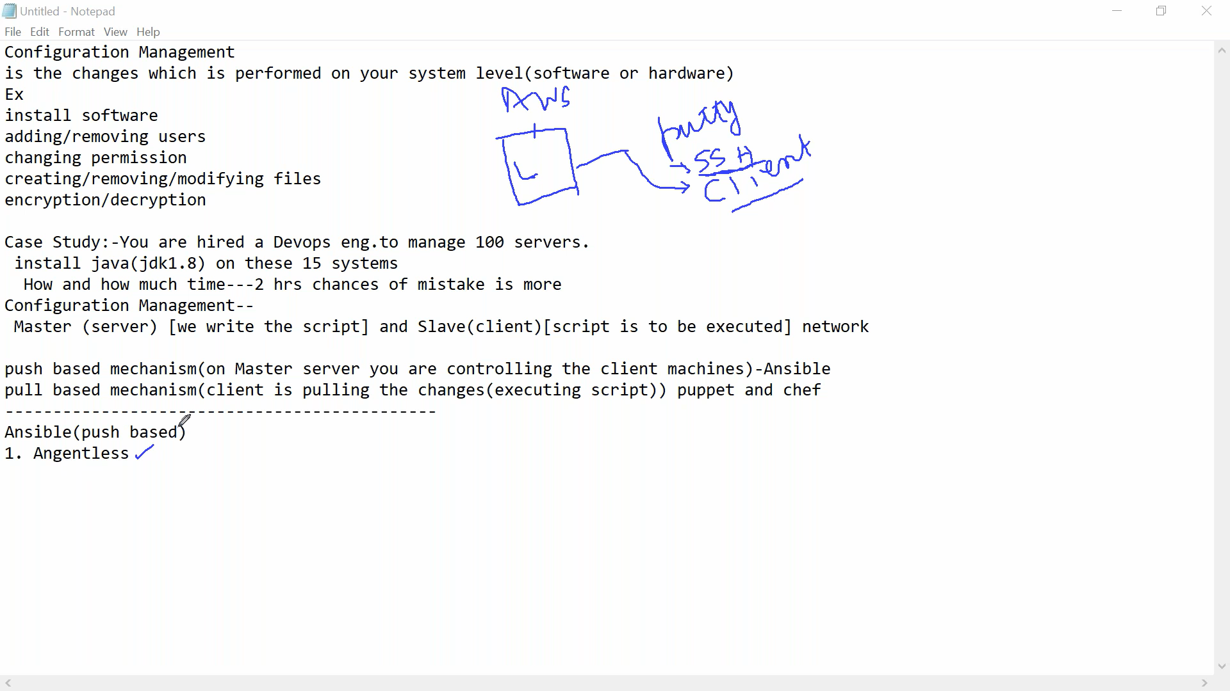

**Ansible**

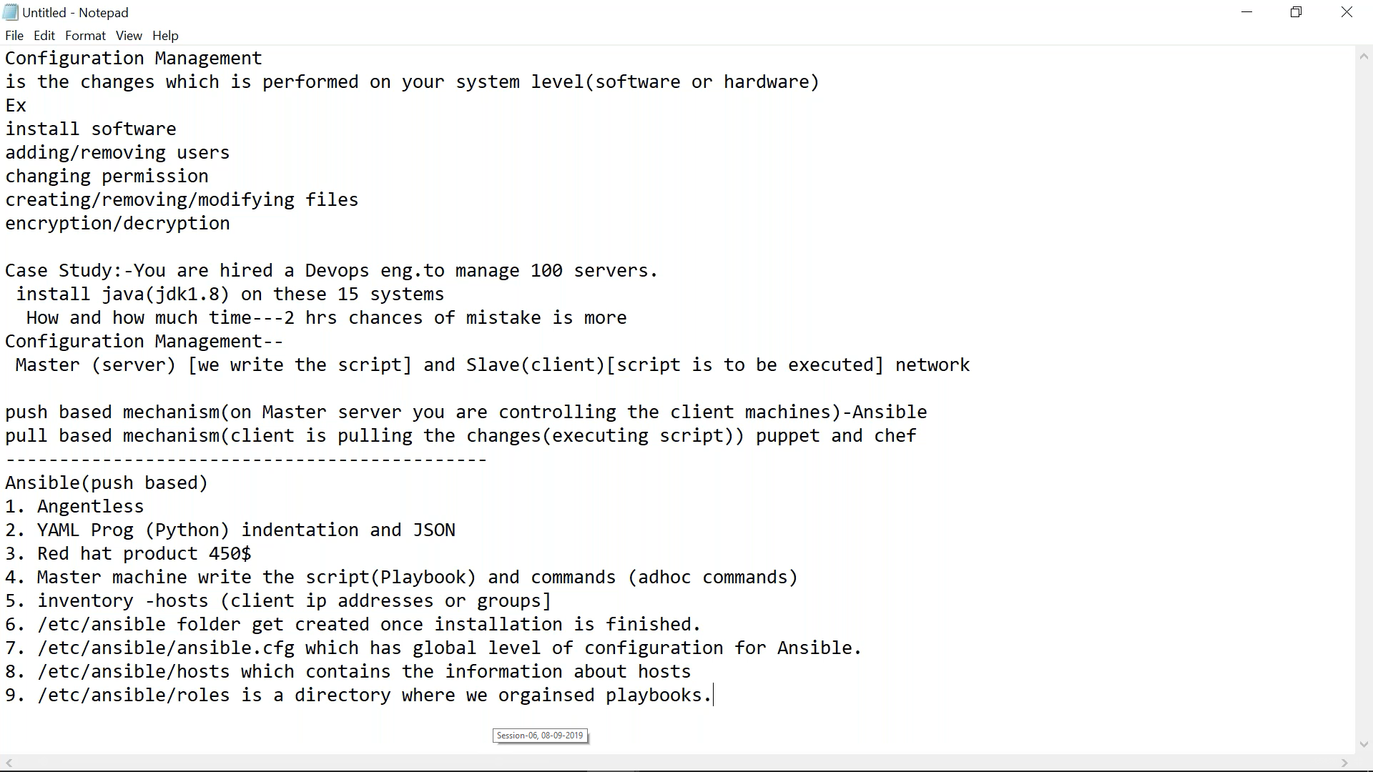

1. While changing hosts file in ansible we use/write private IP of client machine bcz it never change and public ip get changed when we restart machine
2. Ansible works on SSH layer(putty) which fast compared to Puppet(Agent)
3. Every task is Module
4. Adhoc command: single line command and not playbook
5. Tasks are nothing but modules. Similar to ‘shell’ module there is ‘command’ module

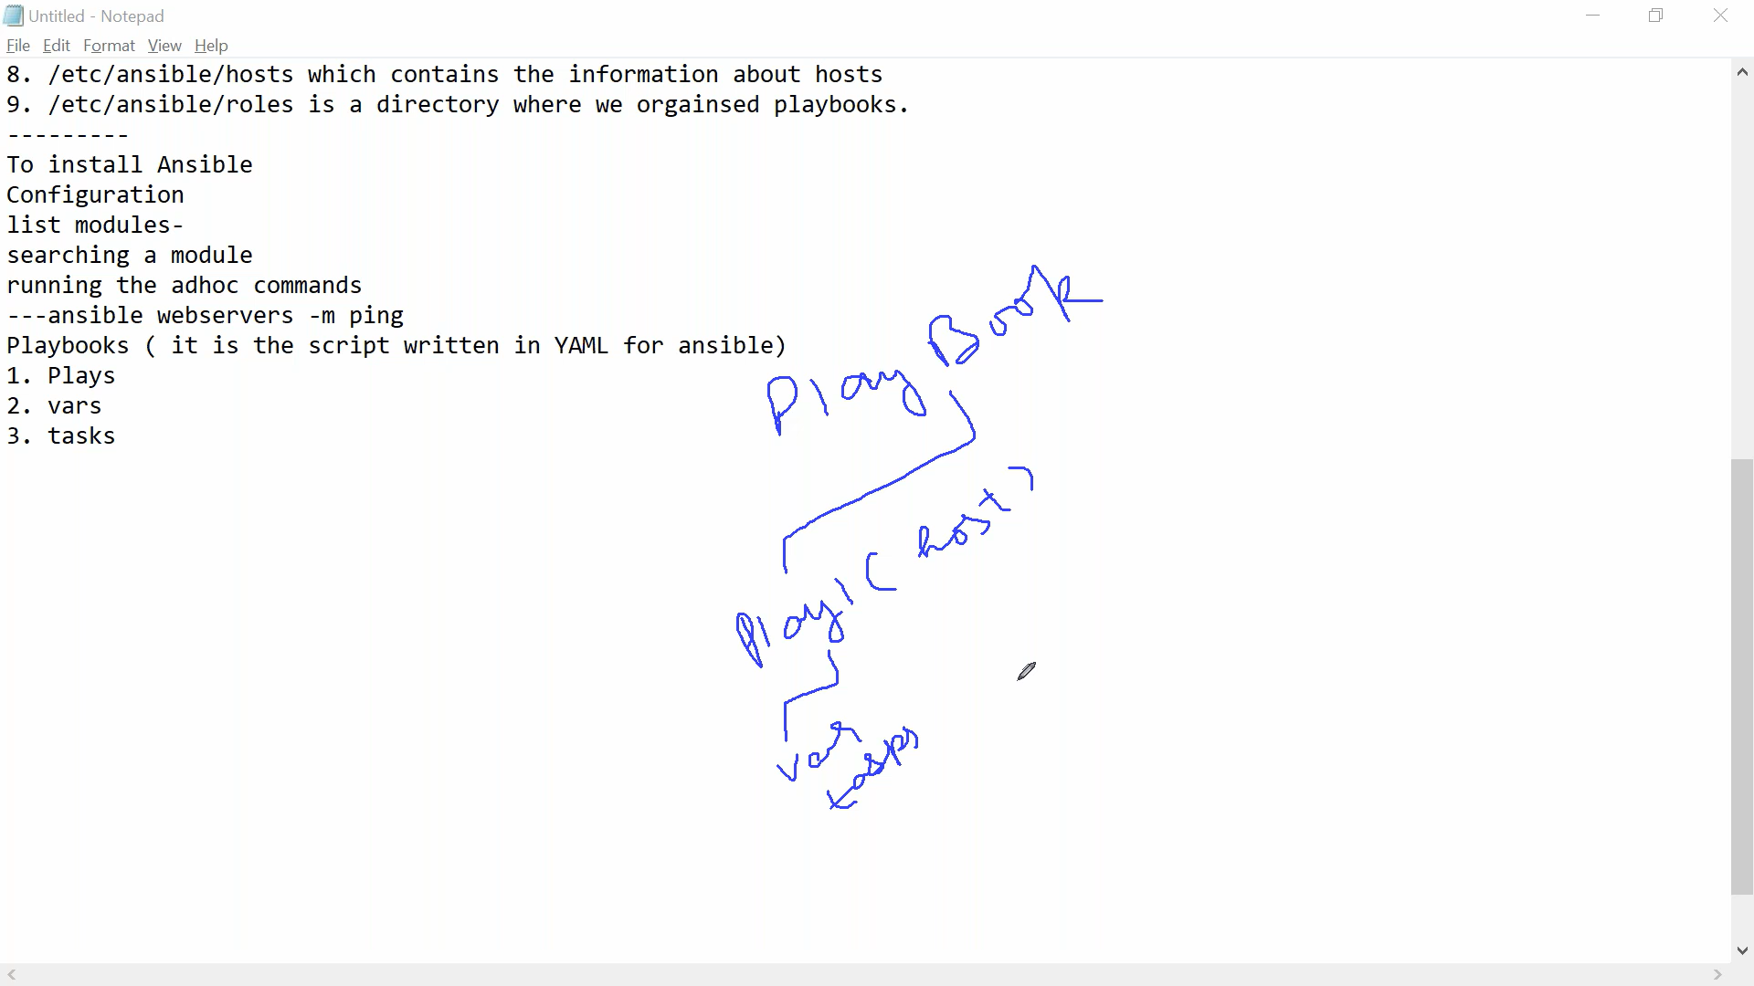

1. Variable is not manadatory part
2. Plays : its nothing but hosts where we need to run the modules/command/tasks
3. Tasks: means command

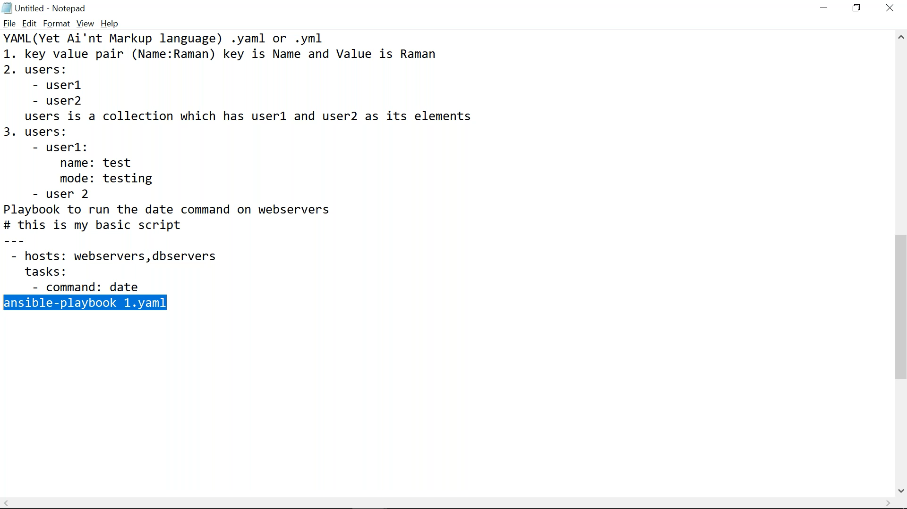

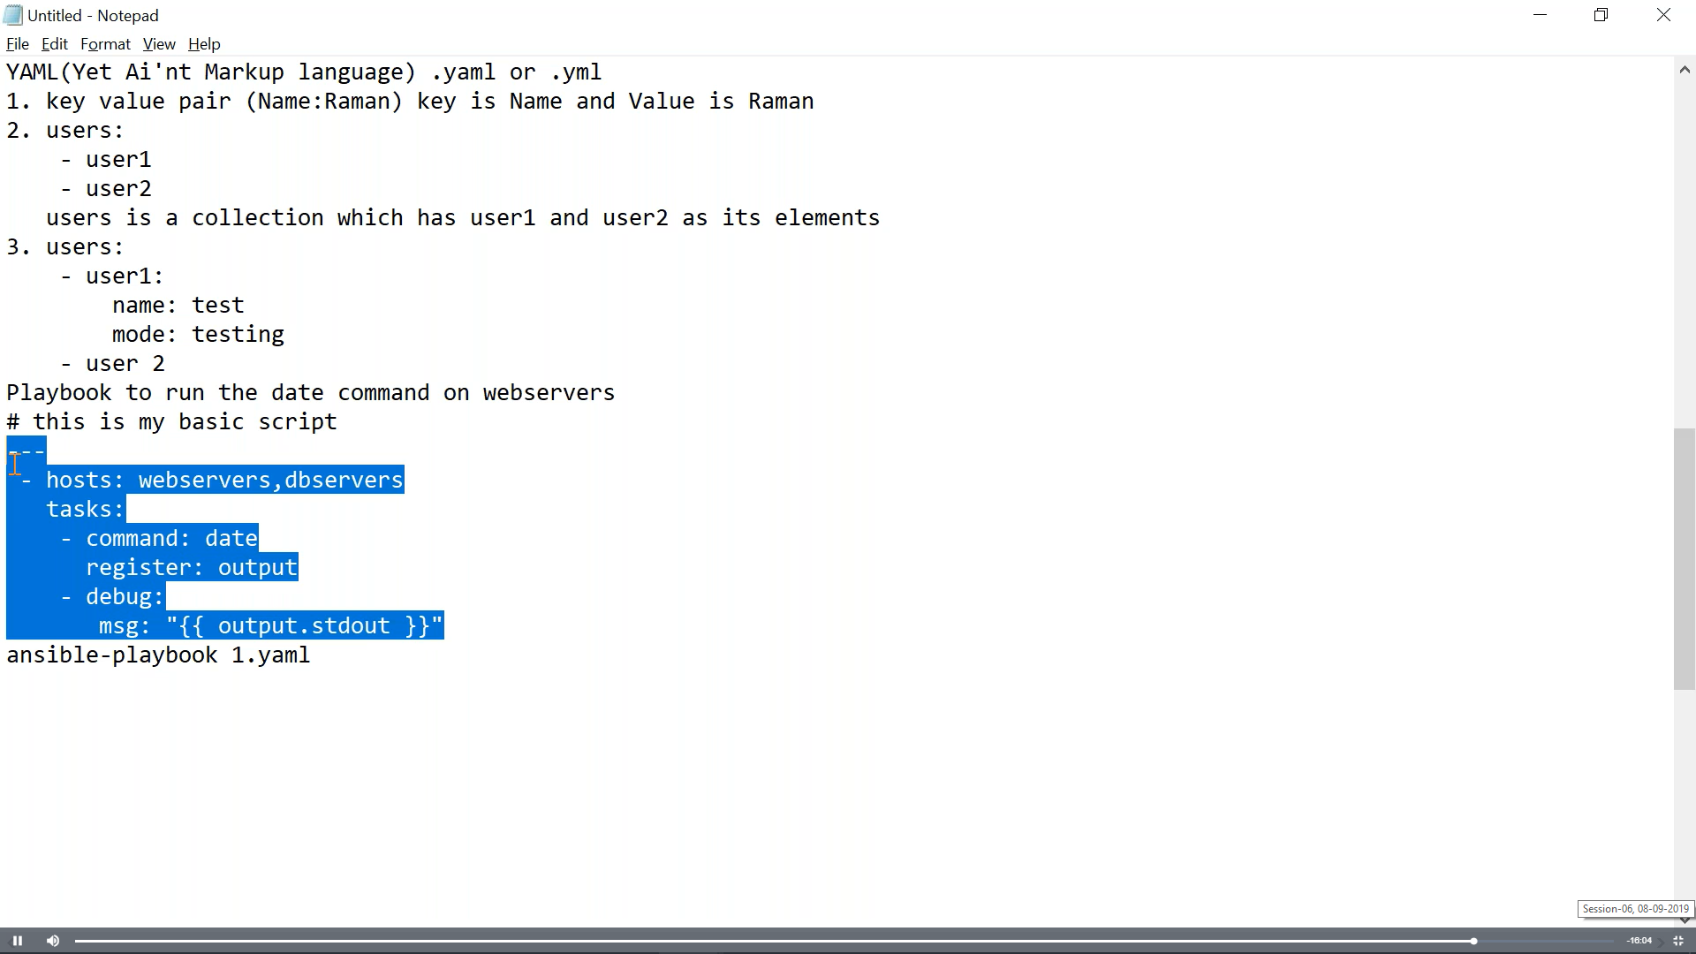

1. Register: it’s a command to create a variable and store the o/p of previous command

Ex:

**Command: date**

**Register: xyz**

Explain:

Date command will execute and Xyz variable has been created which contains o/p of date command.

1. Debug is module which has property msg/var to print
2. .stdout is compulsory before variable
3. Every task should start with hyfan(-)

**PUPPET**

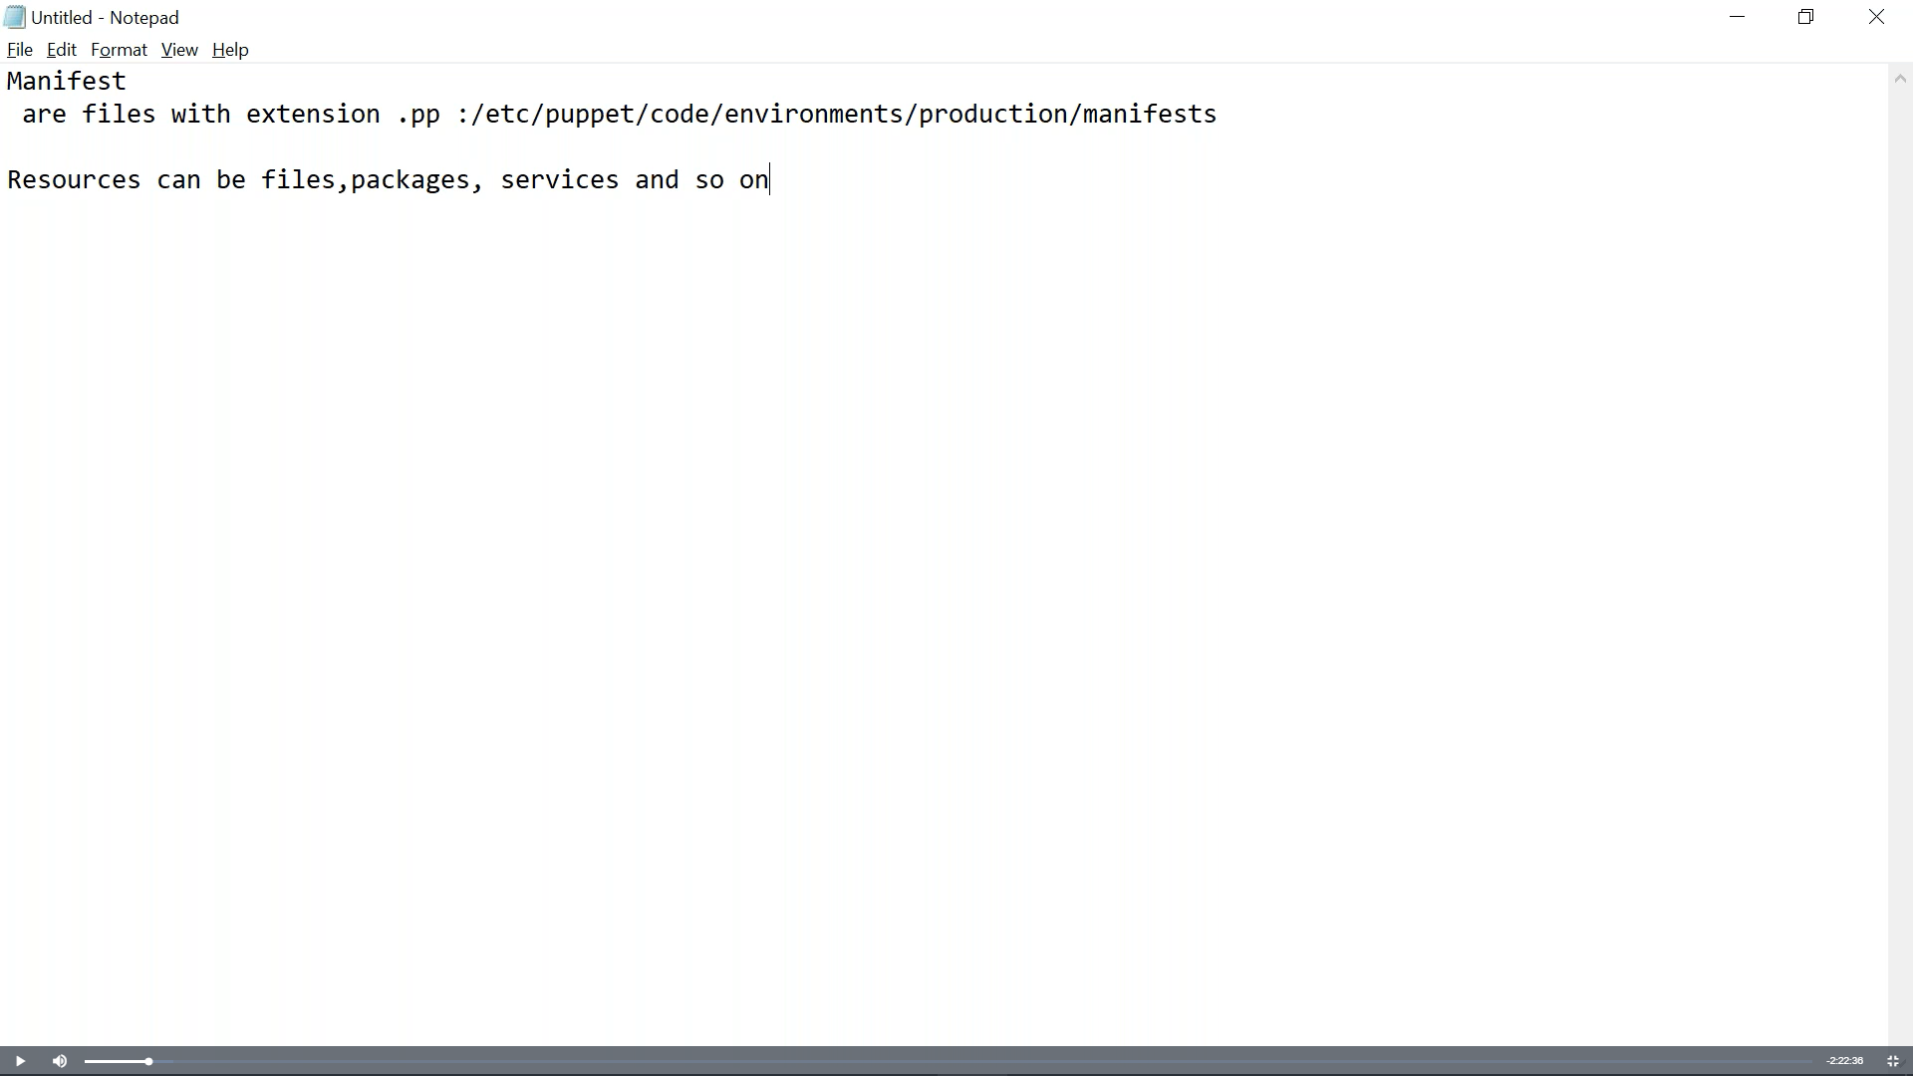

1. Resource is similar to modules in Ansible
2. Puppetcookbook.com
3. Module is collection of manifests(.pp) files
4. Forge.puppet.com-----to download modules
5. puppet.com/docs/puppet/type.html

**JenKins:**

1. google “how to install Jenkins on Ubuntu” <https://linuxize.com/post/how-to-install-jenkins-on-ubuntu-18-04/>
2. combination of plugins only
3. Continous Integration:
4. 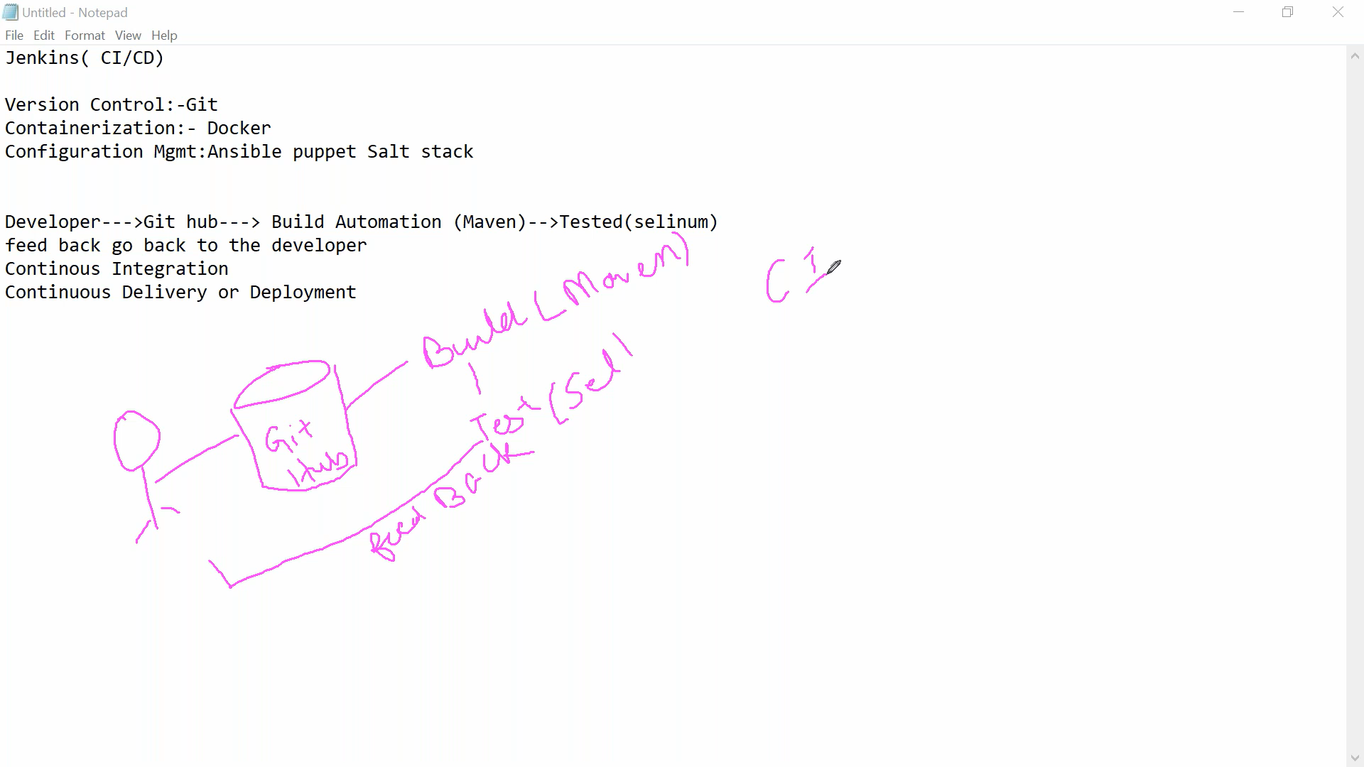
5. whenever u r running any job its running with Jenkins user which has very limited access. So in this case make Jenkins a superuser by adding Jenkins user in sudoers file.
6. How to pull data from git hub on server via Jenkins: mention github clone url in job and build job. So now in server under Jenkins/workspace dir job dir will create and in that code file from github will be available
7. If want to run another job immediately after first job then add/mention the another job name in postjob build section of first Job in Jenkins
8. User Administration, Client Server terminology, Pipeline
9. User Administration: manage genkins>manage users>create user>after user creation> manage genkins>Configure Global Security
10. Plugins: Manage Jenkins>Mange Plugins
11. Roles based(need to download roles plugin) : testing team/dev team/monitor team access
12. Manage plugins>Manage & assign roles > manage Roles/assign roles
13. Manage roles having global roles(admin access), project roles, slave roles
14. In project role there is pattern field where role person can see job started with word mention in pattern
15. 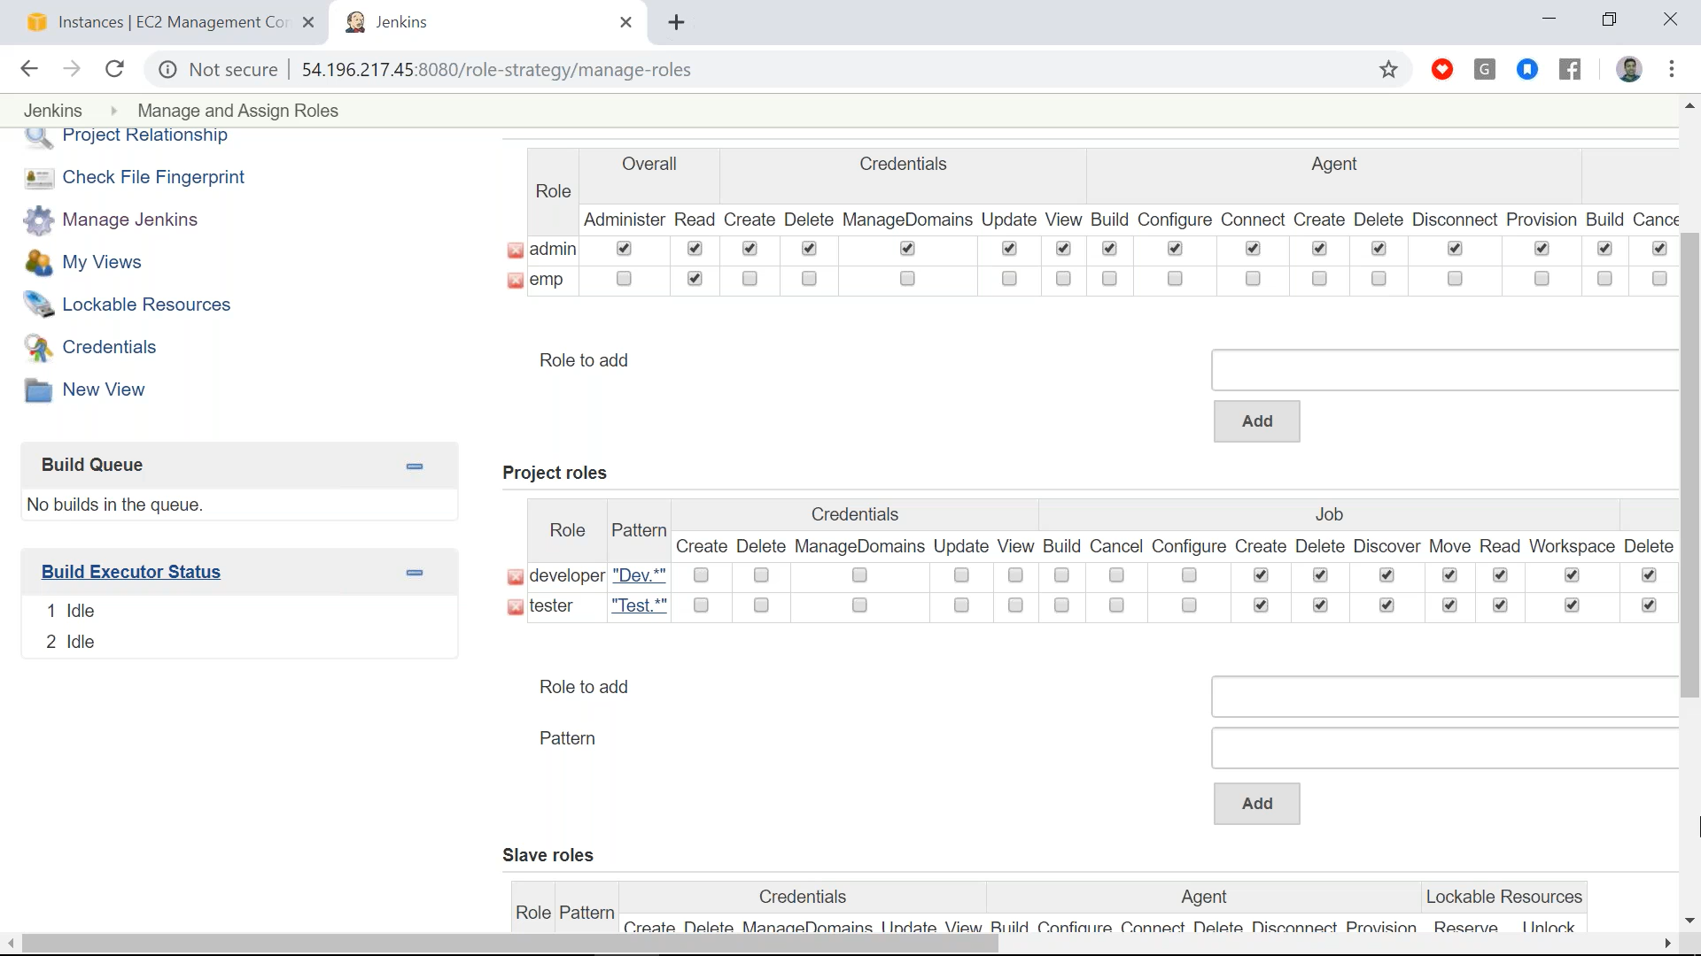
16. Assign roles: here we can assign roles to different user. Means user1 is developer(created in manage roles), user2 is tester(created in manage roles)
17. 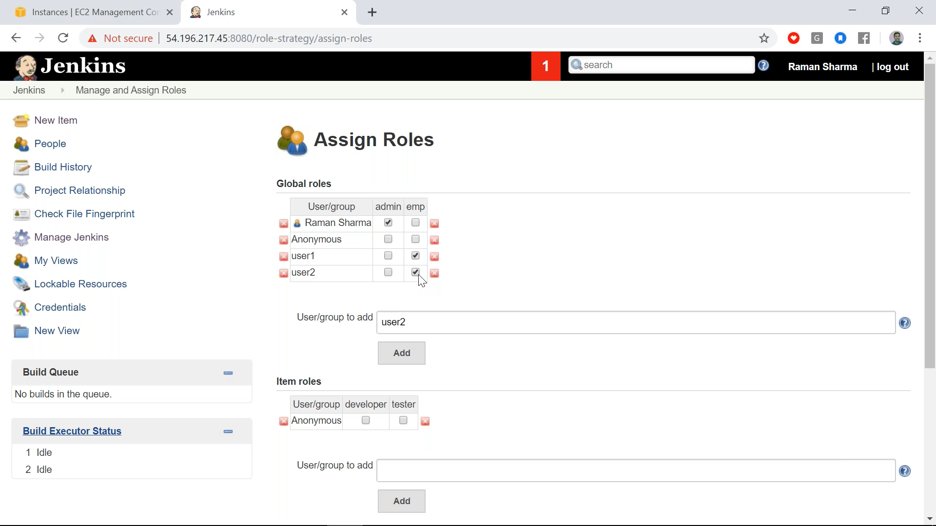
18. 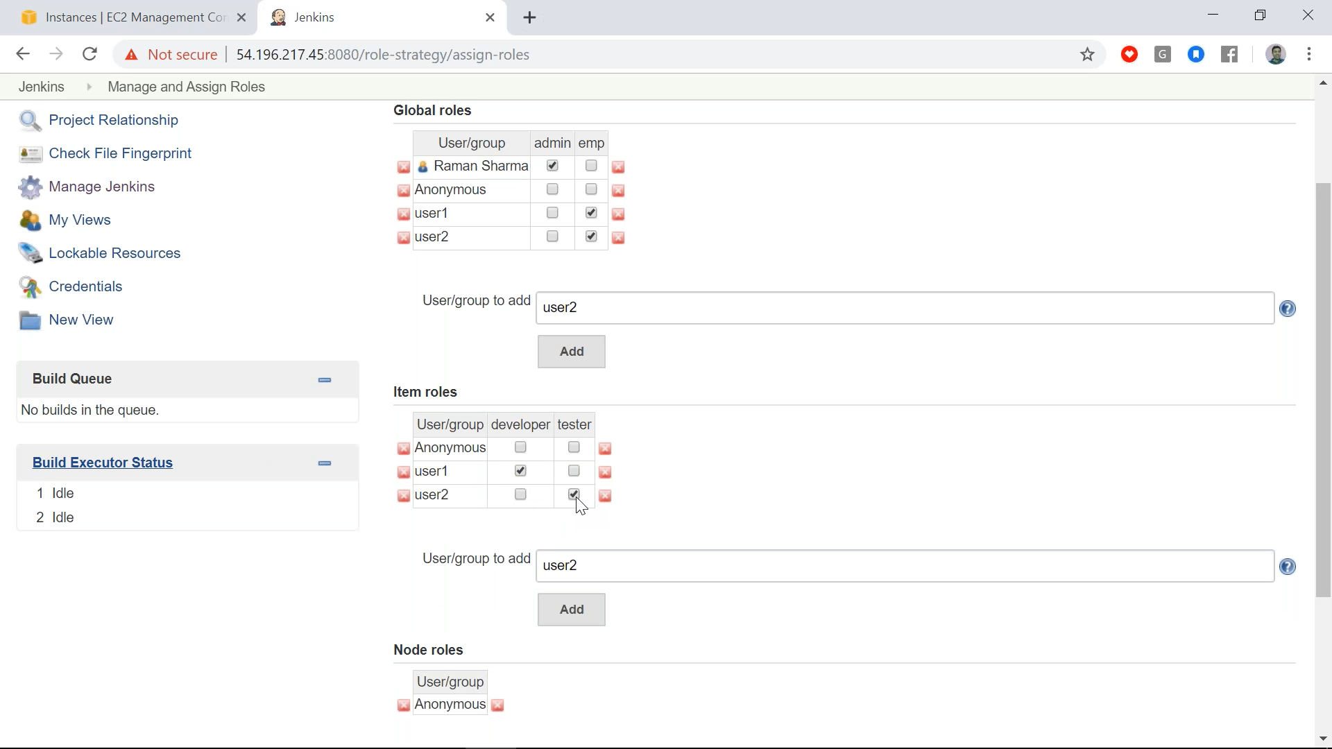
19. Master Slave : for slave only Java installed is required not Jenkins.
20. To connect to slave : manage nodes
21. 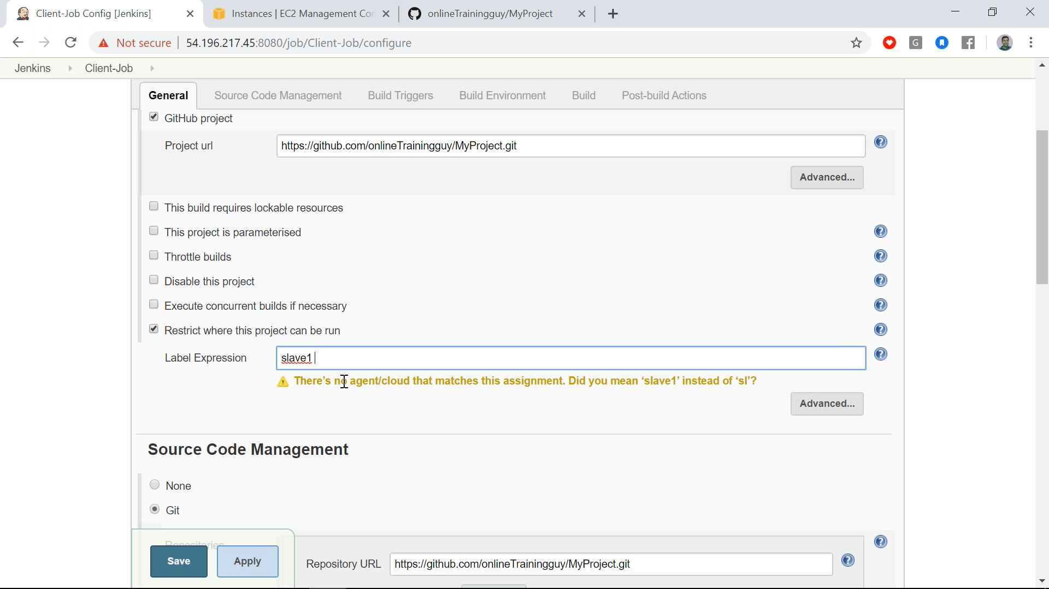
22. To run job on slave we need to mention slave server name in Jobconfiguration

CI/CD Pipeline:

1. Can be created in 2 ways : GUI or code in jenkinsfile
2. 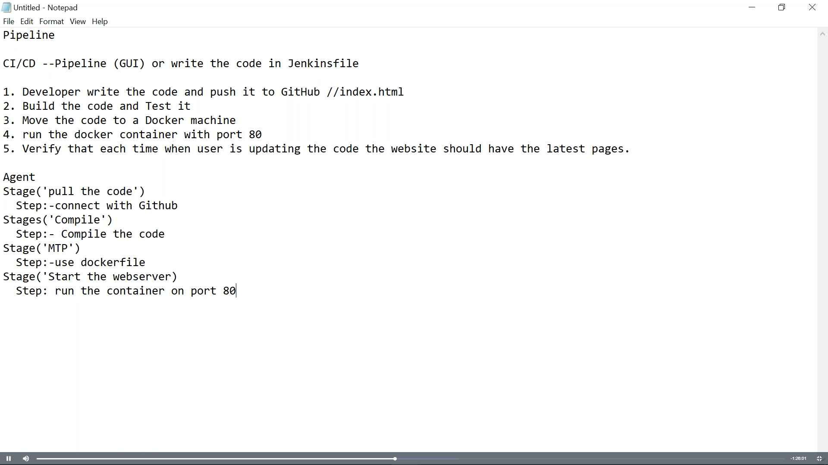
3. Here build code and testing is not DevOps engineer’s job. Tester will provide u the Jar file and u need to configure it in Jenkins.

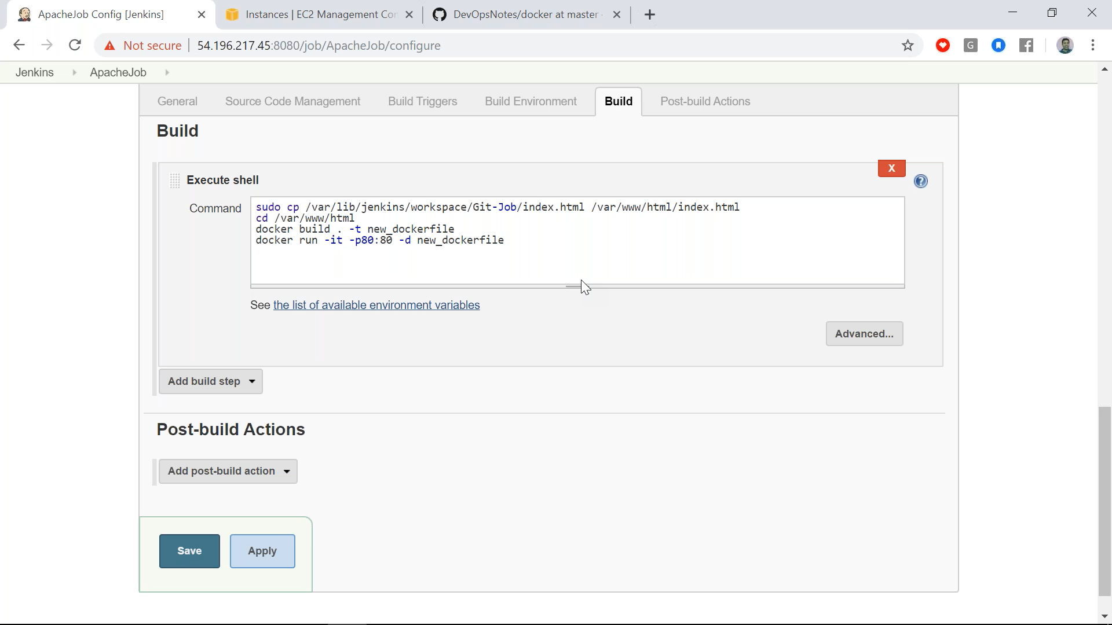

1. Create CICD pipeline:
2. 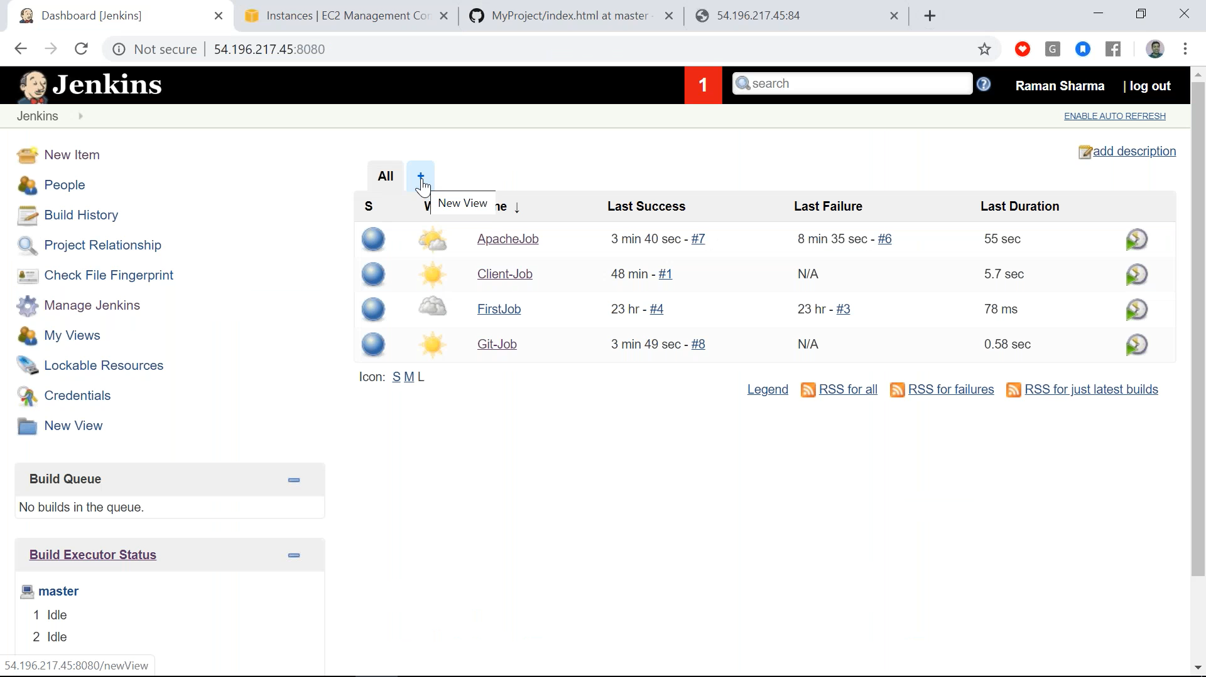
3. 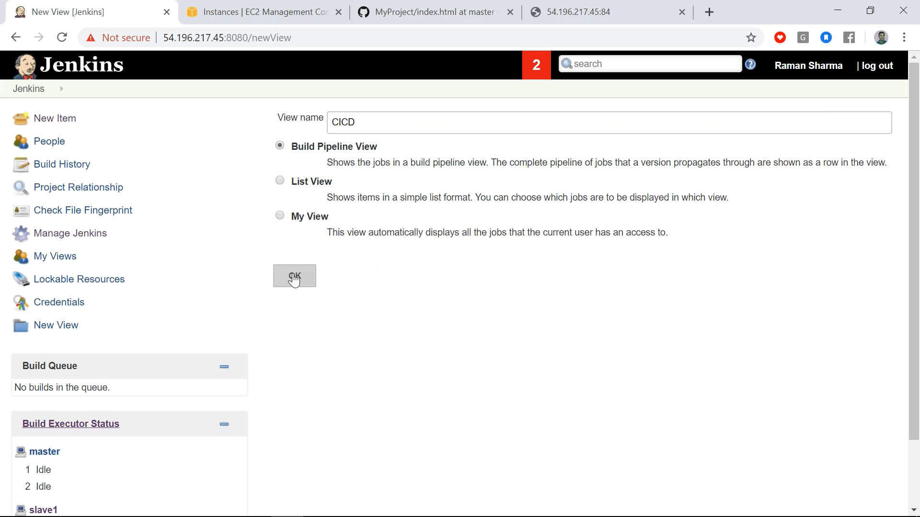
4. 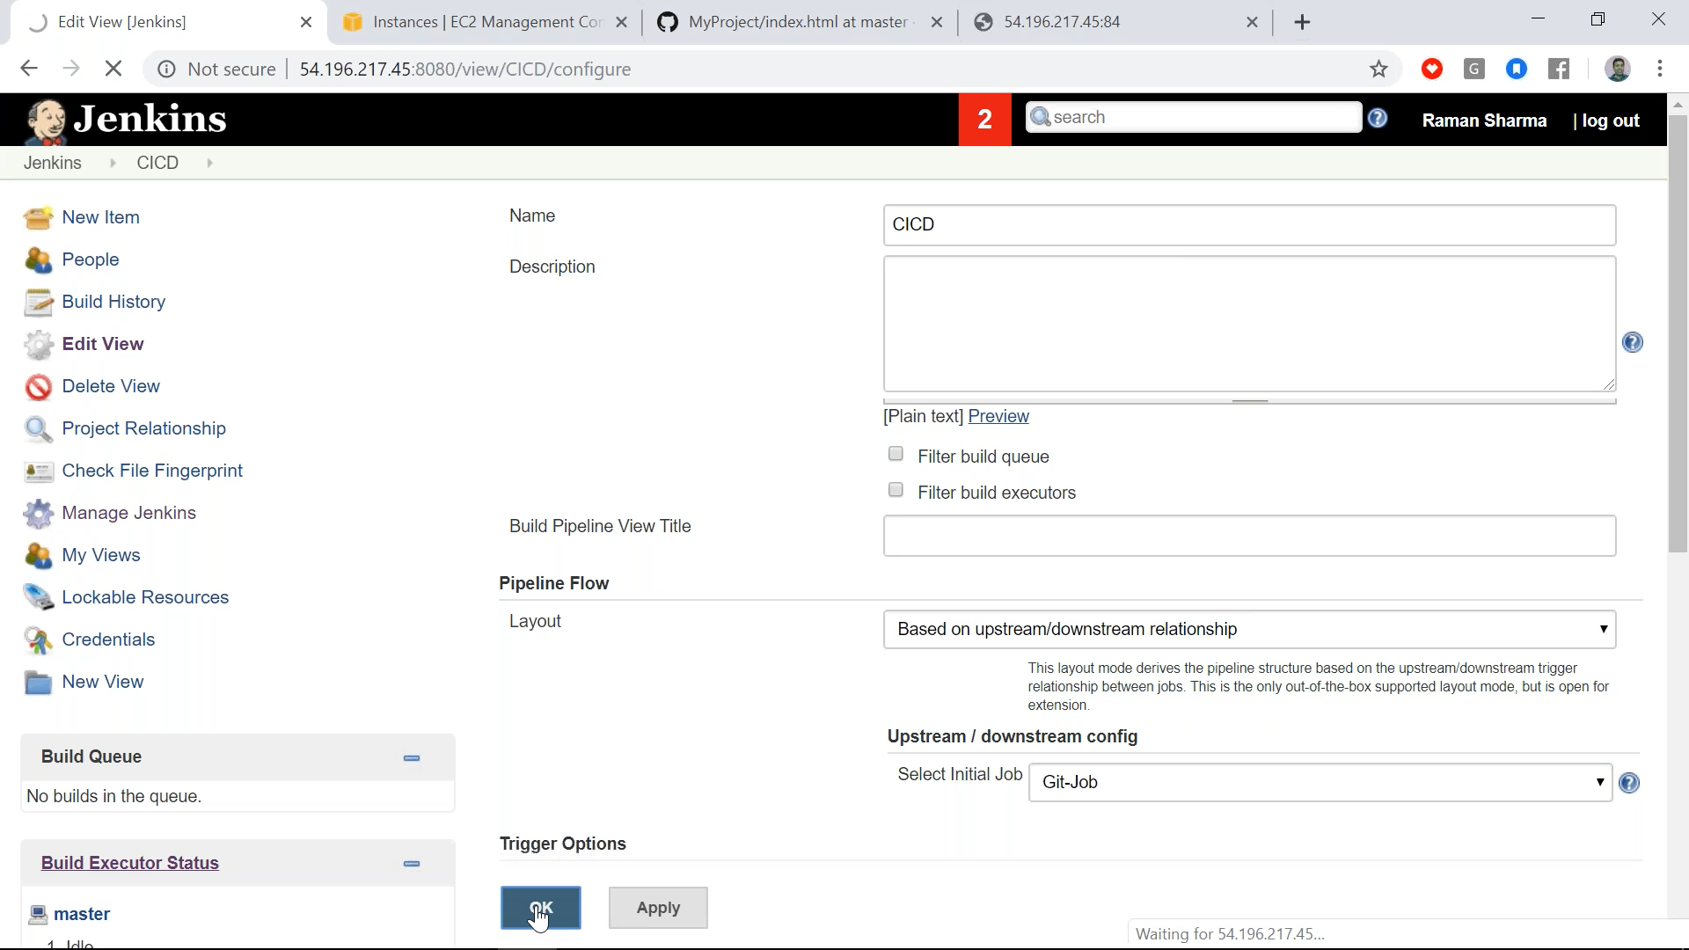
5. 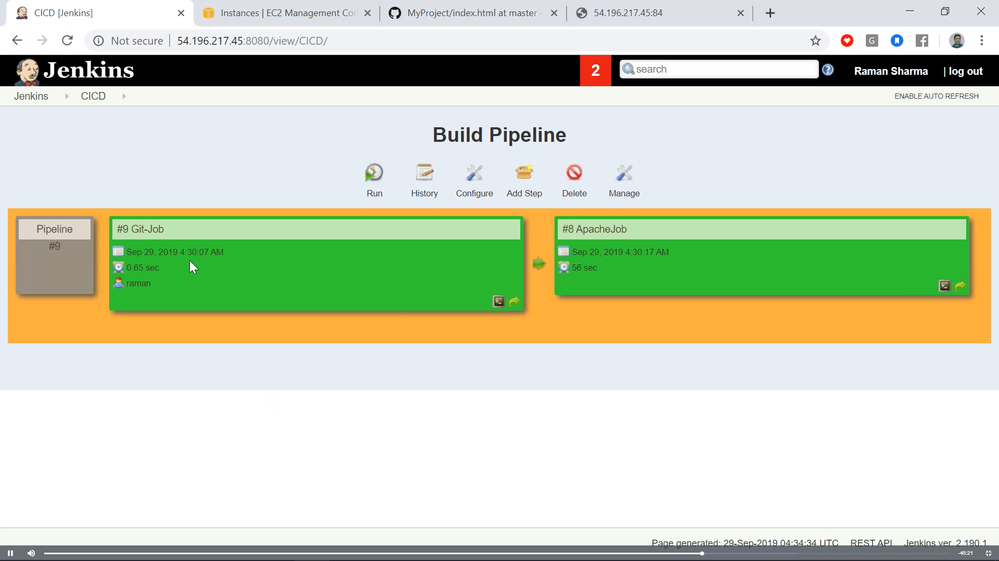
6. For full automation through github setting>webhook(connection between github and Jenkins)>
7. 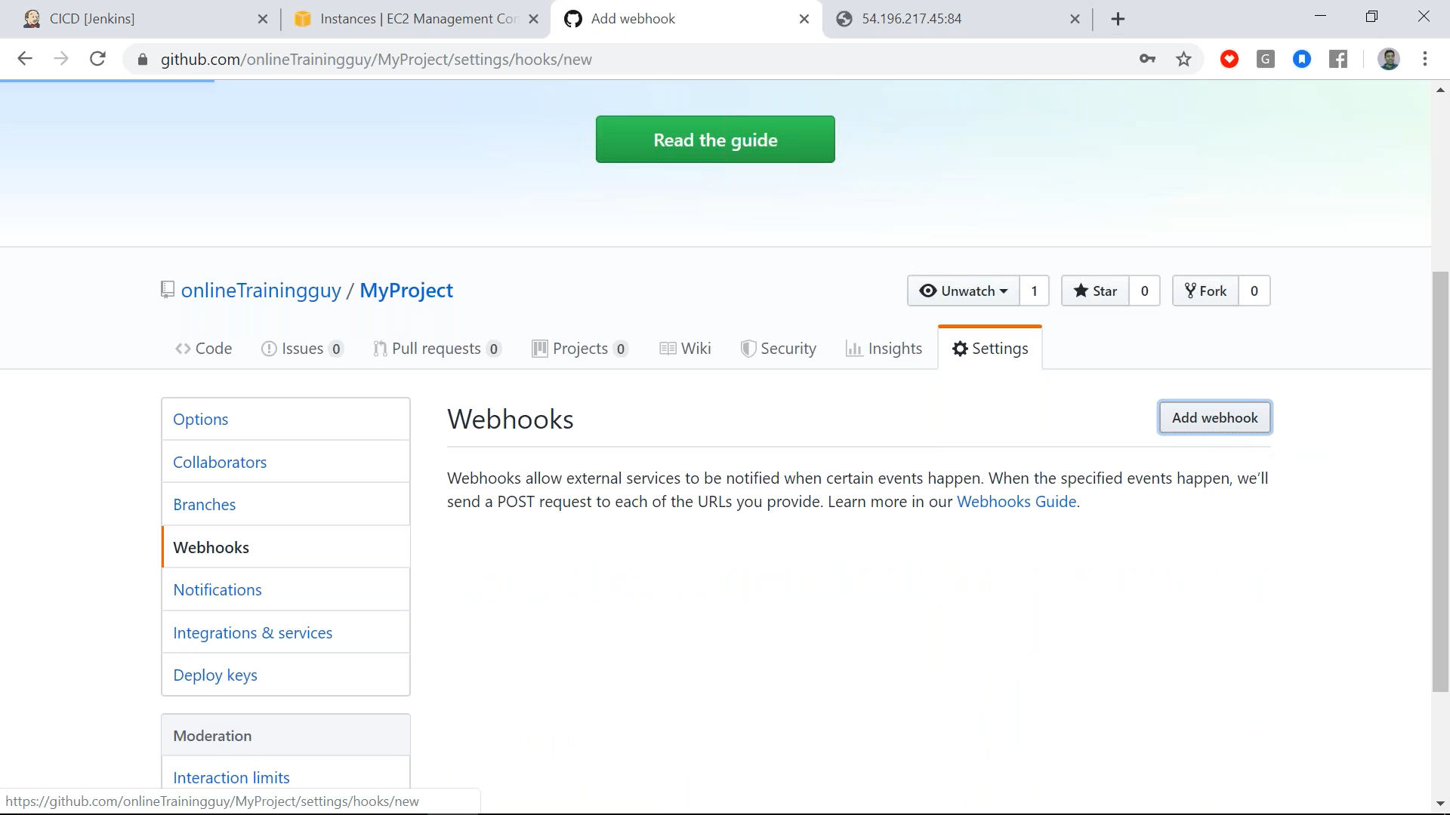
8. 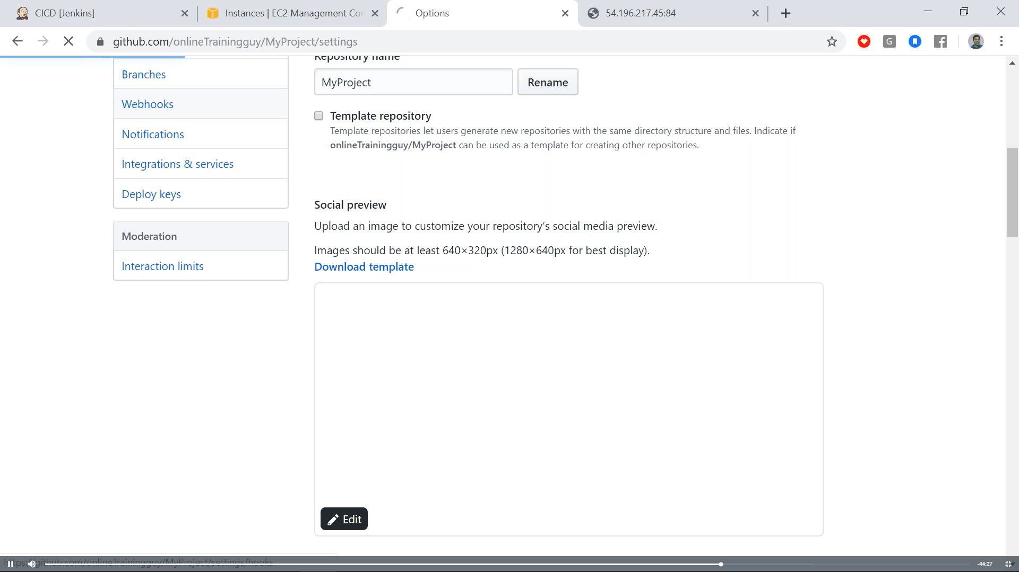
9. 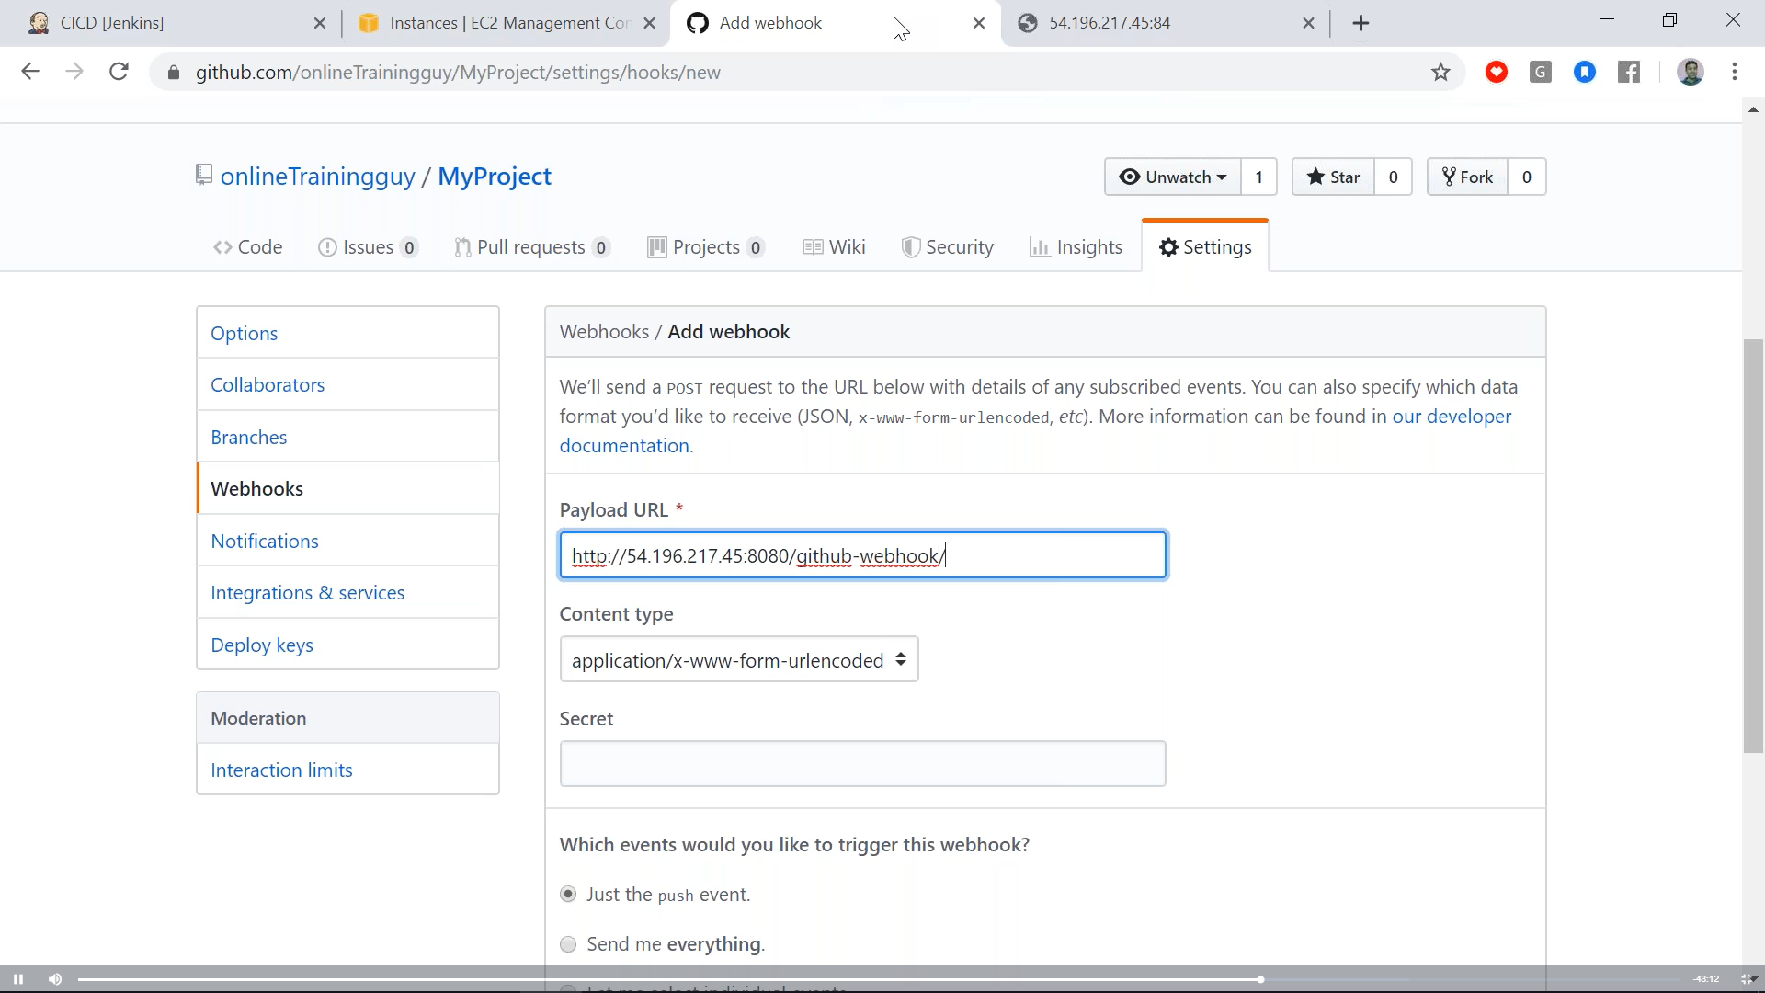
10. 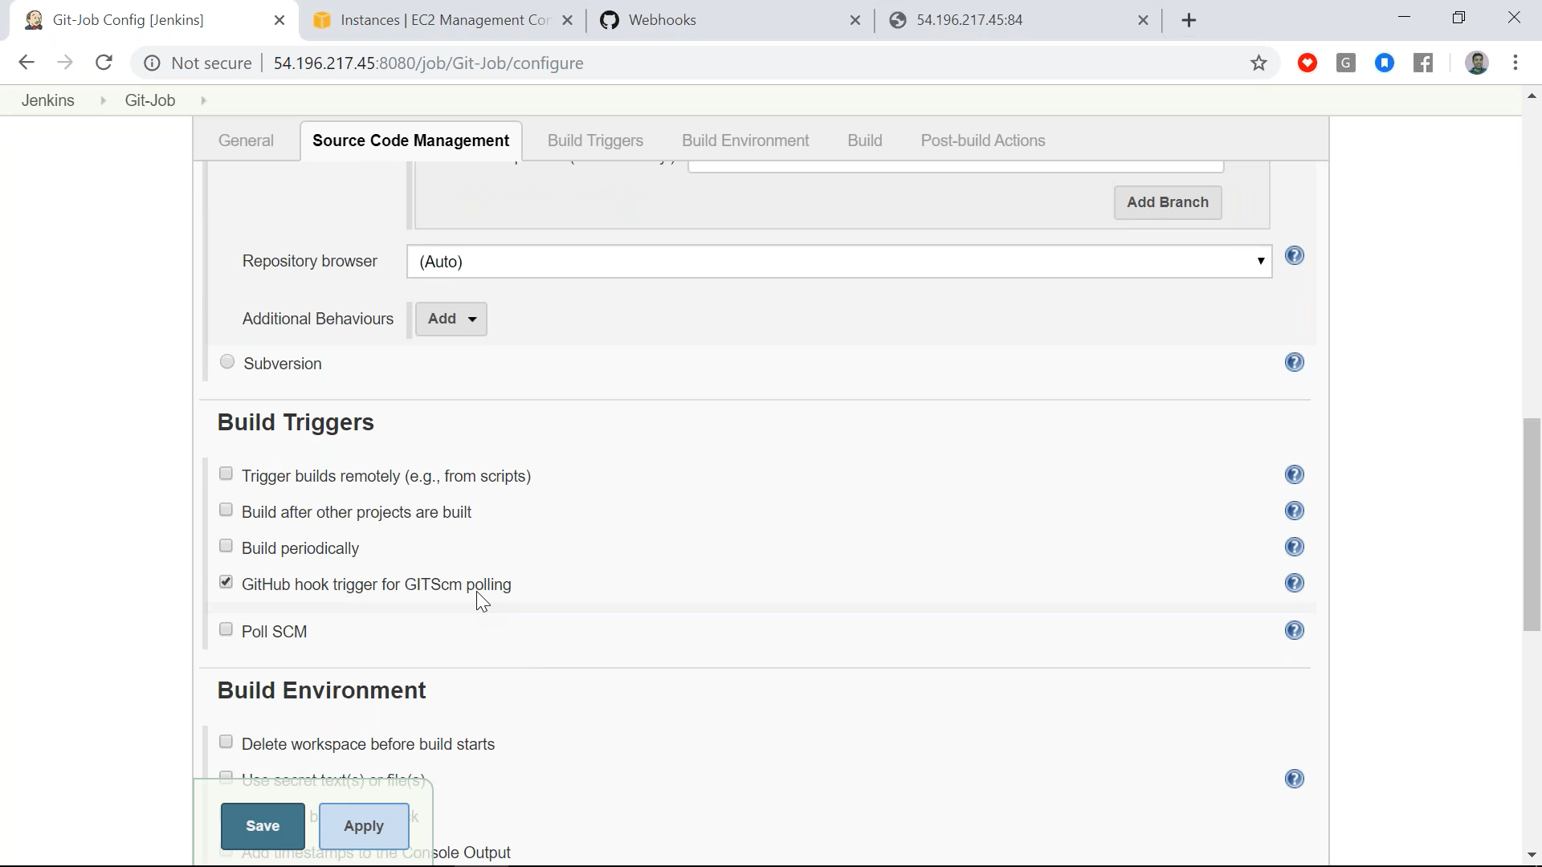
11. Another way: 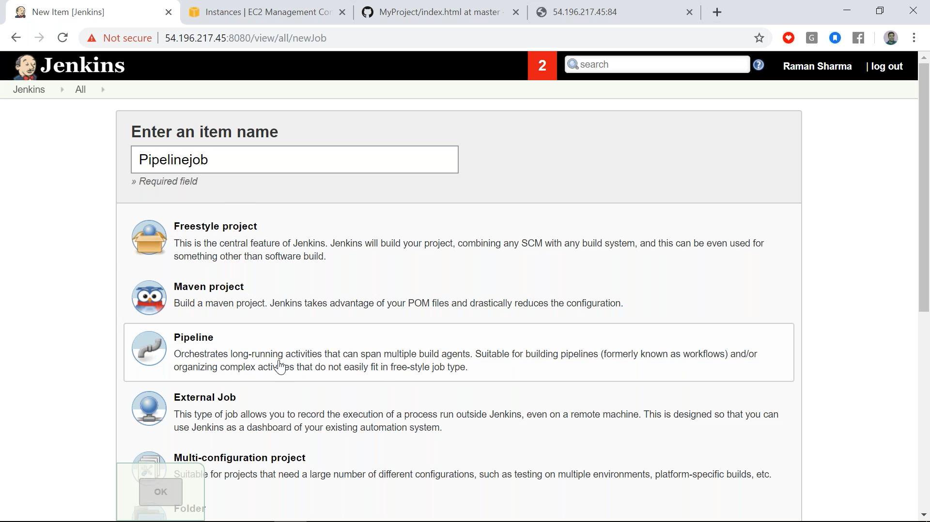

**Kubernetes:**

1. Master Slave function. Master connected to slaves(Node1….Node N)
2. Pod: Collection of containers(VMs/Servers) which are logically connected to each other. Ex. Webserver & Database server
3. These podes are on Node
4. Collections of podes is called pod network and pod network is internal as we can’t access it from outside. To access it services are use. Service also used as Load balancer. Service looks for iptables only as node may be down anytime
5. Kubelet is use to launch pod and it informs Master that container N is running on Pod N. Kubeadm to bootstrap the cluster. Kubectl command line util to talk to clusture
6. Stateless: if we search x on google and it will connect to google server , provide response and disconnected form google server. If again we serach y then new session get created (means same process). This is called stateless.
7. Scaling: If google server is down then our search request connects to replica of google and thus provide us the sreach result. Thus to create create replica of server is called scaling. Scaling(horizontal) is only possible in stateless case most probably in webservers. In statefull case (database server) scalling cannot possible. Here only primary and backup server involved. Means whatever data inserted in primary database server same is inserted in backup database server.
8. Scalling is done in Kubernets through replication controller
9. In services there are ClusterIP(virtual IP can be access only within POD network). NodePort(it is same on each node and can be access externally), LoadBalancer
10. Various methods to install kubernates. We are using kubeadm
11. To create a POD network u need to write a programm
12. Deployment: create, update, stop, resume
13. Install docker on each machine. Curl, kubeadm, kubctl , kublet.
14. Mark it hold
15. Start cluster.
16. Joiun master slave